LAB 1

Answer the following questions

Q#01: Write down the importance of Applied Physics in daily life. Answer should be short and Concise.
Ans: Applied physics plays a crucial role in daily life by advancing technologies that power modern Conveniences, from smartphones and medical devices to transportation systems, and renewable energy resources. It enables innovations that improve, efficiency, safety, and quality of life, making it indispensable in solving real world problems and driving societal progress.

Q#2: Why color is used in resistors?
Ans: Color coding is used in resistors to indicate their resistance value, tolerance and sometimes temperature coefficient.

No 03: If the voltage and resistors are increased in any circuit the current will be increased? Yes, or No. If yes, then why? If no, then why?
Ans: No increasing voltage and resistance in circuit does not necessarily increase current. It depends on the relationship between voltage, resistance, and current, governed by Ohm's law.

Task-01: Design the following circuits on Multisim
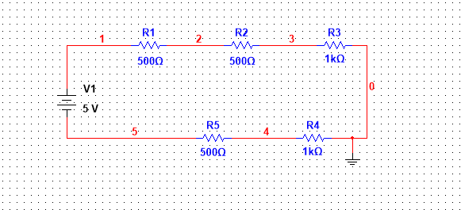

Task-02: Design the following circuits on Multisim
